**Request Date: 2017.05.18**

Changes:

New VAS Split Request module to handle lots sends to clean room for main product splitting process. , handle for HK migration

Customer requirement:

The concept is as below.

-          Import Split request,

- Generate on VAS email request picklist

-          Daily scan status report to monitor on cut off timing on split request column K & L.

-          Manage SFG trays usage after request completed.

Development 1st week June

Target : Mid June

Requirements:

1.     Import files – Split request.xls

Develop new screen to import VAS Split request.

2.     Generate on VAS email request picklist

System generate pick list – auto email VAS Pick list. New tableName = “MICRONVAS”

>New Pick list requirement:

1 import file excel = 1 pick list, follow excel sorting sequence.

Title: Micron VAS Pick List – Split Request

Add summary signature:

Picked By

Processed by

Verified by

3.     No Scanning is required.

User will close the Split request by update status close or update FG Date-time like OFI Scan.

>> update close status screen.

4.   Daily scan status report to monitor on cut off timing on split request column K & L

Daily VAS Split request report – similar to Daily scan status report.

5. Master Tray design Usage table

New tray maitainance screen for user to manual update/ maintain Stock qty

6. Manage SFG trays usage after request completed. – Phase 2

6.1 Auto – minus Tray Design consumption qty in Tray master list,

Tray Usage.Tray design = for split request column J (Tray design).

Development Changes:

## Master Tray Design

SCH_OFI_VAS_TRAYDESIGN - Master Tray Design Usage Table:

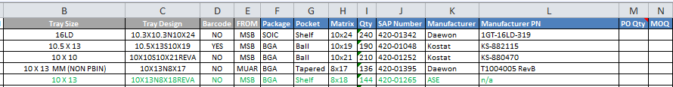

Primary key = TrayDesign

Import function –

If new TrayDesign – insert new data

Else update TrayDesign information.

|  |  |
| --- | --- |
| Tray Size |  |
| Tray Design |  |
| Barcode |  |
| FROM |  |
| Package |  |
| Pocket |  |
| Matrix |  |
| Qty |  |
| SAP Number |  |
| Manufacturer |  |
| Manufacturer PN |  |
| PO Qty |  |
| MOQ |  |
| StockOnHand |  |
| Usage |  |

## Import VAS Request

* New import screen – refer screen u_micron_import_so_rebag / u_micron_import_so

Object Name u_micron_import_ofi_vas

* Fields mapping - WMS_Interface File Mapping_Micron_20170519.xlsx

BU = VASSPLIT

* After import generate Printjob ( like split request)
* Function _ of_insert_printjob()

INSERT INTO dbo.TransmitLog ( transmitlogkey, tablename, key1, transmitflag )

VALUES ( :ls_getkey, ‘MICRONVAS’, :as_key1, '0' )

USING TransactionObject;

## VAS Pick list

Generate VAS email request picklist

1. System generate pick list – auto email VAS Pick list. New tableName = “MICRONVAS”

Existing EOD application

1. Create New Datawindow – Pick list

R_report_ofi_vas_picklist

>New Pick list requirement:

1 import file excel = 1 pick list, follow excel sorting sequence.

Title: **Micron VAS Pick List – Split Request**



Add summary signature:

Picked By Verified by

Processed by

## Daily Scan Status Report

* Use existing

SCH_OFI_OUTBOUND_SO_LOT

BU = VASSPLIT

## Summary Tray Usage report – new

Description:

Generate summary report of Tray Design usage by range of add date.

Source table:

**SCH_OFI_OUTBOUND_SO_LOT, Status = ‘9’**

BU = VASSPLIT

Retrieve by:

Date from – to

Tray Design # of Usage

Sample:

Excel import format:



Tray Usage

